1. **Wedding arrangement**

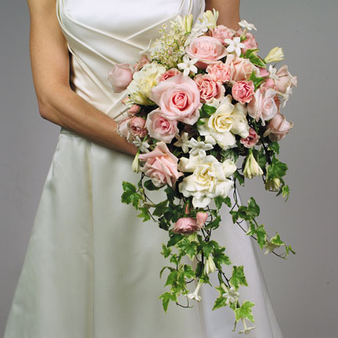

Happy marriages begin when we marry the one we love, and they blossom when we love the one we married.

1. **Watch the film**

**How to create wedding flowers**

**Answer next questions.**(Dutch)

1. What foliage is used for the bouquet?
2. 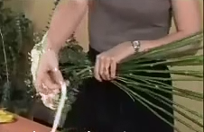What method will be used in making this bouquet?
3. What kind of preparation do you make?
4. What do you strip away?
5. How long do you cut the foliage stems?
6. What are beaded wires?
7. At what angle do you cross the foliage?
8. What must you do with the free end of the string?
9. At what length do you cut the stems finally?
10. What again was the colour of the roses?

Back in the book is the script of this film (#2). Read it

1. **Instructions: How to Tie a Wreath Bow**
   * *1*

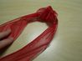

Cut a 10- to 12-inch length of wired ribbon. Tie a loose knot about 2 1/2 inches wide in the center. Set aside.

* + *2*

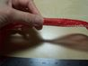

Measure 8 to 10 inches from the end and pinch the ribbon between your thumb and forefinger.

* + *3*



Form a loop measuring 5 inches long. Pinch and twist the ribbon and form a loop opposite from the first loop.

* + *4*



[Continue](http://www.ehow.com/how_4480158_tie-wreath-bow.html) pinching, twisting and forming new 5-inch loops.

* + *5*



Pick up the knotted ribbon length that you made first. Place the knot in the center of the loops. Wrap the ends around the center toward the back.

* + *6*



Turn the loop mass upside-down. Pull the ends of the knotted length up in the center.

* + *7*

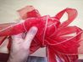

Tie the ends at the center of the loops.

* + *8*

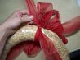

Tie the ribbon to the wreath and knot it securely.

* + *9*

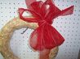

Turn the wreath around and pull the tails to the area where you want them to hang down.

* + *10*

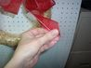

Fold the tail ends in half lengthwise. Then hold between your thumb and fingers and snip off at an angle with shears.

* + *11*

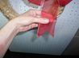

Unfold to find the notched end.

* + *12*

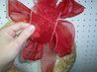

Shape the bow by pulling the loops open.

**Assignment: *Make this knotted ribbon***

|  |  |  |  |
| --- | --- | --- | --- |
| 1. Tools and accessories | | | |
| http://www.floraldesigninstitute.com/images/image004.11.02.81.04%20Wet-Foam.gif | http://www.weddingflowersandreceptionideas.com/media/images/discount-florist-supplies/ss_size2/discount-florist-supplies16.jpg | http://www.floralsupply.com/media/catalog/product/cache/1/image/9df78eab33525d08d6e5fb8d27136e95/f/p/fpccutters1.jpg | http://garden-items.jardins-animes.com/images/circle-wreath-topiary-frame.jpg |
| A | B | C | D |
| http://www.bloemschikshop.com/data/mediablocks/2__85_ms1.rvf_1.jpg | Over Door Wreath Hanger | http://www.jamaligarden.com/images/detail/k1_DT_DN.jpg |  |
| E | F | G | H |
| http://2.bp.blogspot.com/_fOHzze0vS5c/TCOCaFLU3HI/AAAAAAAAAI4/5sApfz_RMs8/s1600/wire-easel.jpg |  | http://www.sdflowers.com/images/20ga_wire.jpg | http://firstflowersonline.co.uk/shop/images/Stem%20Stripper%20Yellow.jpg |
| I | J | K | L |
| http://1.bp.blogspot.com/_xuPekGQd7BE/TOlq9v4DfgI/AAAAAAAAAAQ/faYvCc5YO08/s320/FMS+Underwater+Stem+Cutter.jpg | http://www.shopscissors.com/images/productImages/154/large/35000.jpg | http://www.pkgspec.com/images/ribbon/ribbonshredder_lg.jpg | http://www.weddingflowersandmore.com/images/supplies/floral-tape-green.JPG |
| M | N | O | P |

|  |  |  |  |
| --- | --- | --- | --- |
| **Put the right letter in the right place** | | | |
|  | Candle sticks |  | Bloemenlijm |
|  | Floral adhesive |  | Bloemenspeld |
|  | Floral foam |  | Bloementang |
|  | Floral pliers |  | Bloementape |
|  | Floral tape |  | Doornstripper |
|  | Flower pin |  | Draadezel |
|  | Ribbon shredder |  | Kaarsenhouders |
|  | Stapler |  | Kransframe |
|  | Stem cutter |  | Kranshaak |
|  | Stem stripper |  | Lintsplitser |
|  | Stem wire |  | Niettang |
|  | Tape roller |  | Plakbandroller |
|  | Thorn stripper |  | Steekschuim (oase) |
|  | Wire easel |  | Stengeldraad |
|  | Wreath frame |  | Stengelsnijder |
|  | Wreath hook |  | Stripper |

1. **Make a presentation**

Prepare a presentation for next class. You have to use PowerPoint for a slide show and give your own comment. Make at least 8 slides.

1. Introduction of yourself
2. Introduction of the subject (work/internship)
3. The situation and colleagues
4. Favourite activities
5. Activities you dislike
6. What is going well
7. What is going not so well
8. Special events
9. finish